Mathematics Specialist Unit 2
Test 6 2018

Section 2: Calculator Assumed
Instructions: Show all working clearly, in sufficient detail to allow your answers to be checked and for part marks to be awarded for reasoning. Calculators are permitted.
Time Allocation: 40 mins Total Marks: /35
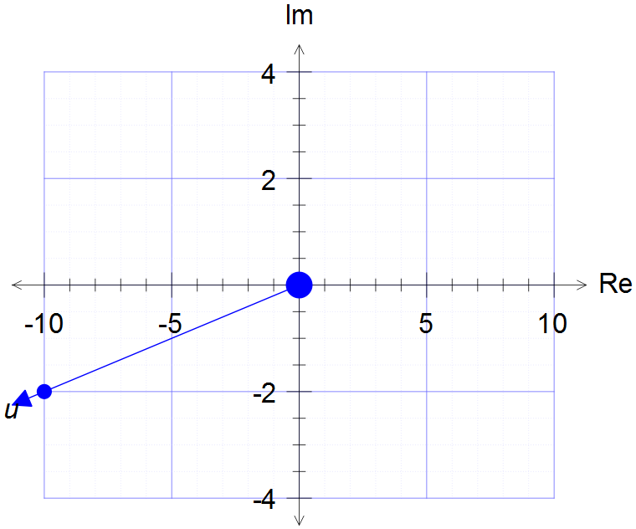
1. [3 marks: 1, 1, 1]
The complex number is shown on the Argand diagram to the right.

a) Express in the form 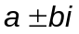.

b) State the equation of in the form

c) Show on the Argand diagram.

2. [8 marks: 3, 2, 3]
Given that w = 3 - 2i and z = 4 + 3i, determine:

a) 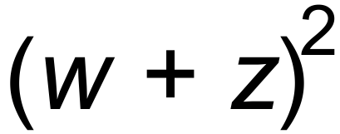 c) 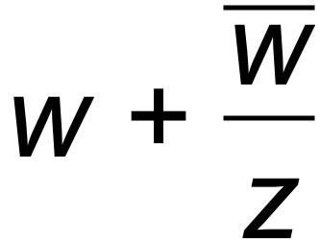

b) 

3. [4 marks]

Solve the equation to find Z. (Hint: Let 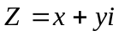)
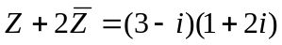

4. [5 marks: 2, 2, 1]

The transformations S and F are represented by 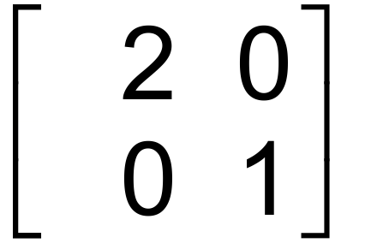 and 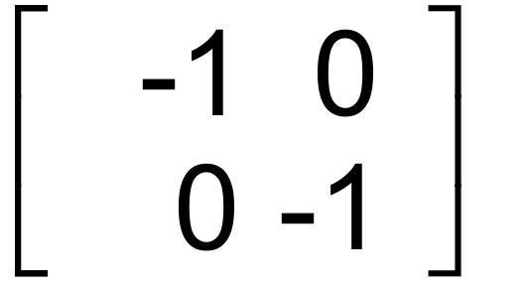 respectively.
a) Find the single matrix that represents the successive transformations S then F.

b) Find a single matrix that will reverse the sequence of transformations in part a).

c) Hence, or otherwise, find the point whose image is (8, 4) under the sequence of transformations in part a).

5. [6 marks]

The triangle with vertices O (0, 0), A (2, 0) and B (0, 3) is mapped to the triangle O’A’B’ by the transformation represented by the matrix 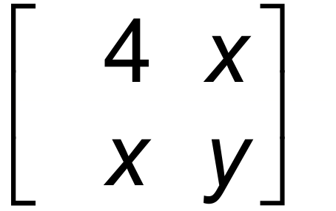. The area of triangle O’A’B’ is
36 cm² and A’ has coordinates (8, 0). Find the value of x and y.

6. [4 marks: 3, 1]

a) All points on the line 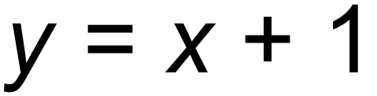 are rotated 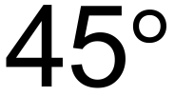 clockwise about the origin. Find the equation of the image line.

b) Find the single transformation matrix that will reverse the transformation described in part a).

7. [5 marks: 2,3]

- Find the matrix representation of a combination of linear transformations that map the points (1,0) to (-2,0) and (2,1) to (-3,1).

- Show that it is not possible to find a combination of linear transformations that will map (1,0) to (3,0), (2,1) to (4,1) and (3, 1) to (5,1).

END OF SECTION 2

